**Exercise 4-5 celebA DCGAN**

Jirayu Petchhan, D10907801

Hyper-parameter and dataset selection (default setting)

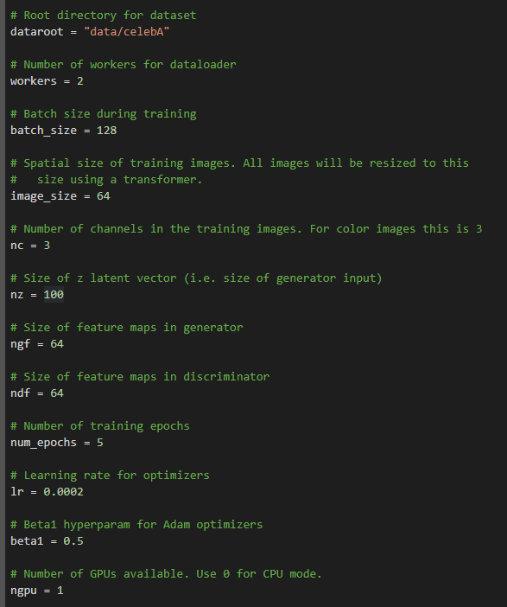

The result of DCGAN training with celebA dataset

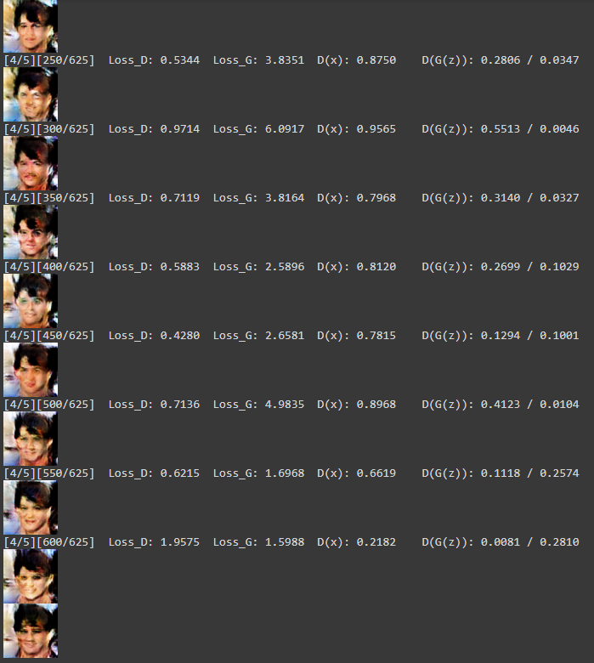

result of G and D loss

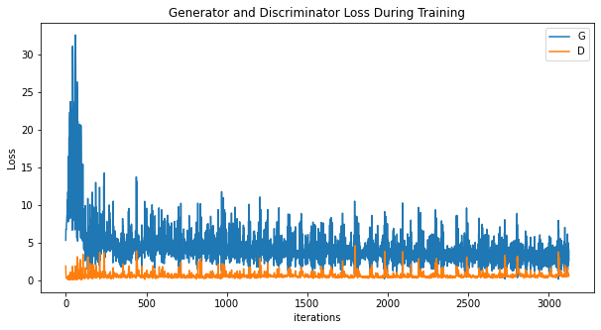

Visualization of G’s progression

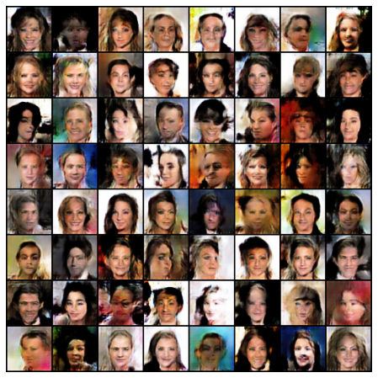

Real vs fake

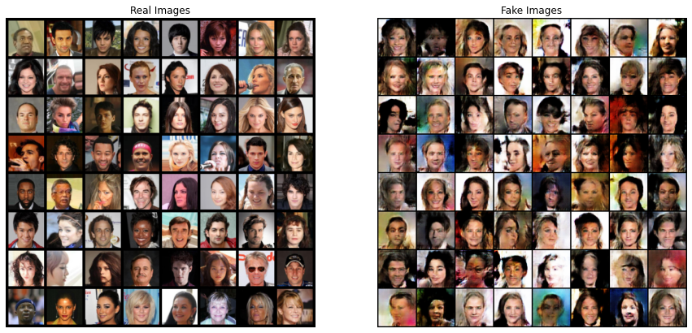

Now we will start train with LSUN dataset

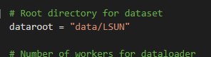

Change image size from 64 to 32 for transforming as image input treat to model.

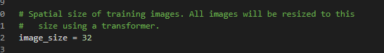

Download dataset LSUN dataset

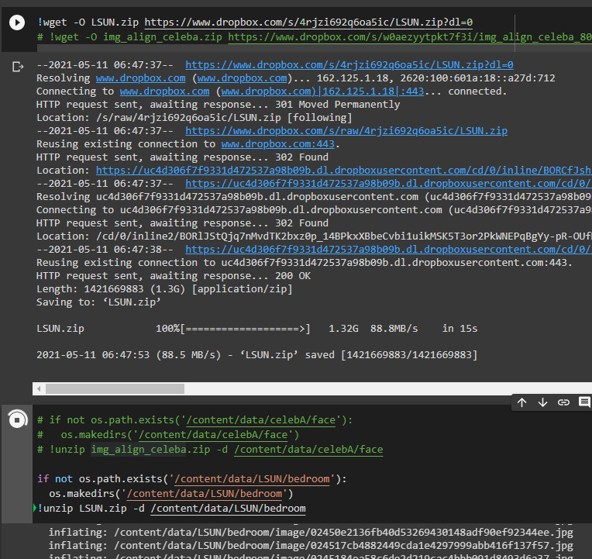

Generator same as 4-4

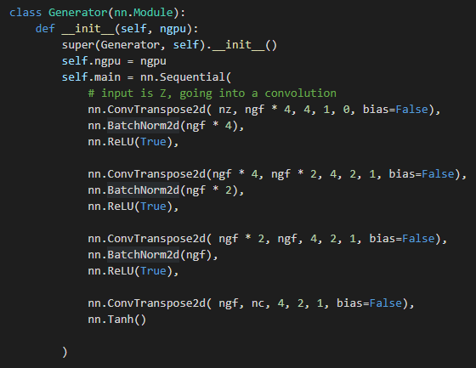

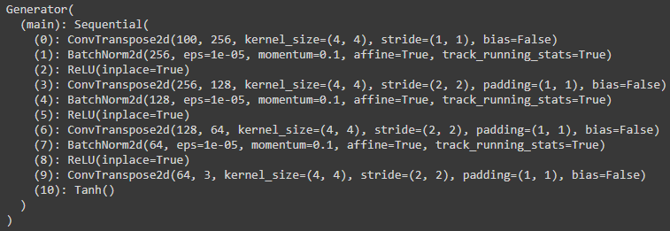

Discriminator same as 4-4

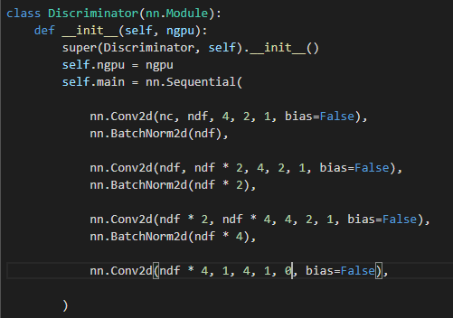

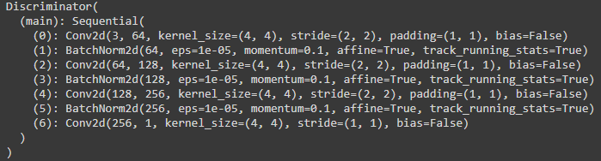

Optimizer and loss function same as the default setting of exercise 4-4

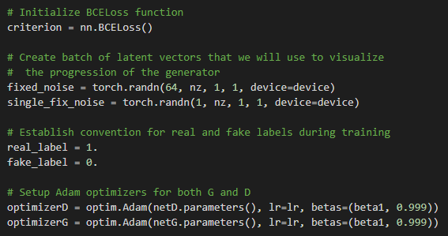

**Training phase**

Exemplary of source sample

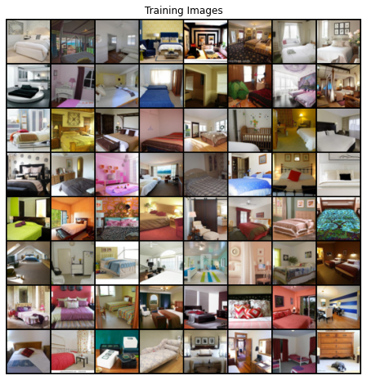

Training result **(50 epochs)**

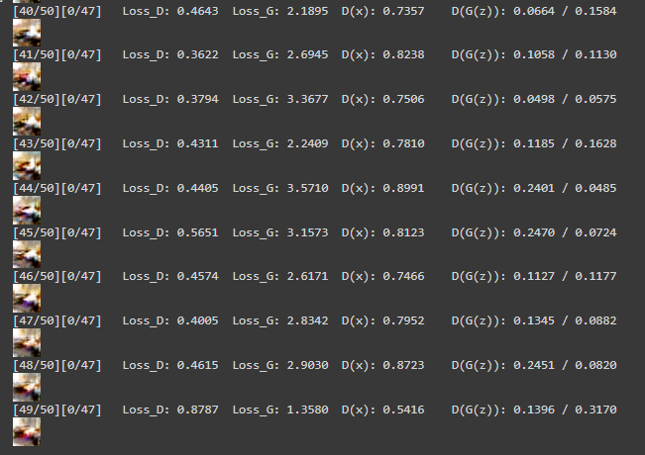

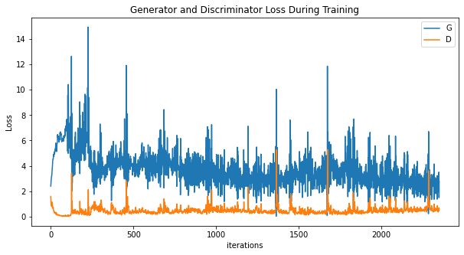

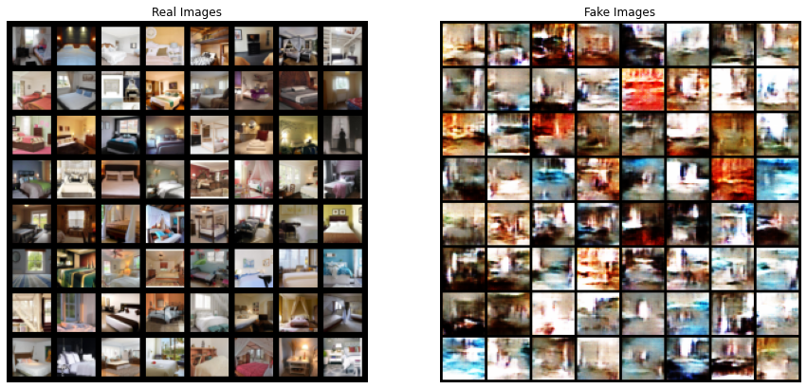

Training result **(100 epochs) starting at 51th epoch from the latest training**

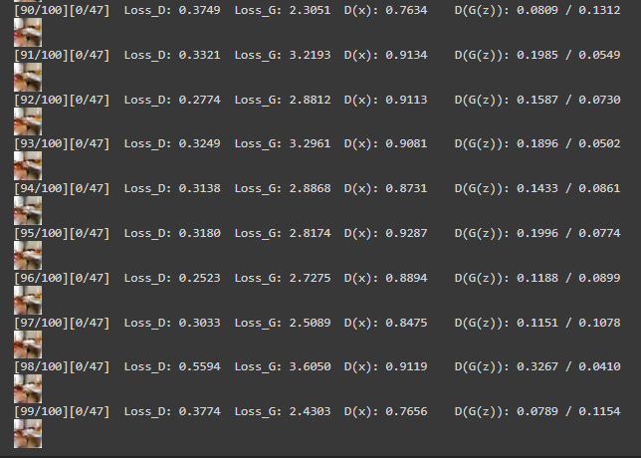

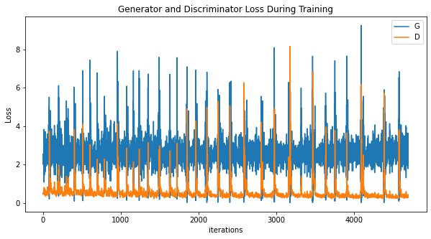

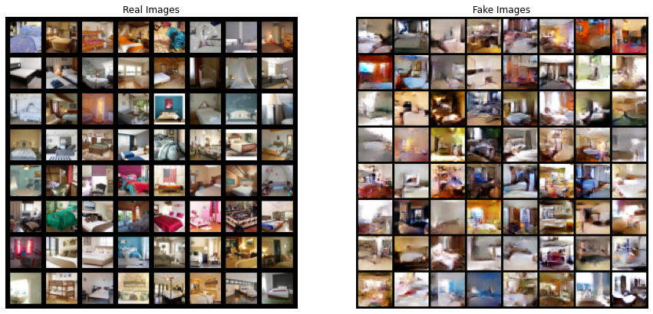

**Conclusion**

As the result, we tried to train two set i.e., 50 epochs and 100 epoch time. We got the generated fake image when training a lot of iteration, when we trained continue from 50th epoch. we got the convergence of loss after 51th epoch.